Q4 – Function Module:

Structure:

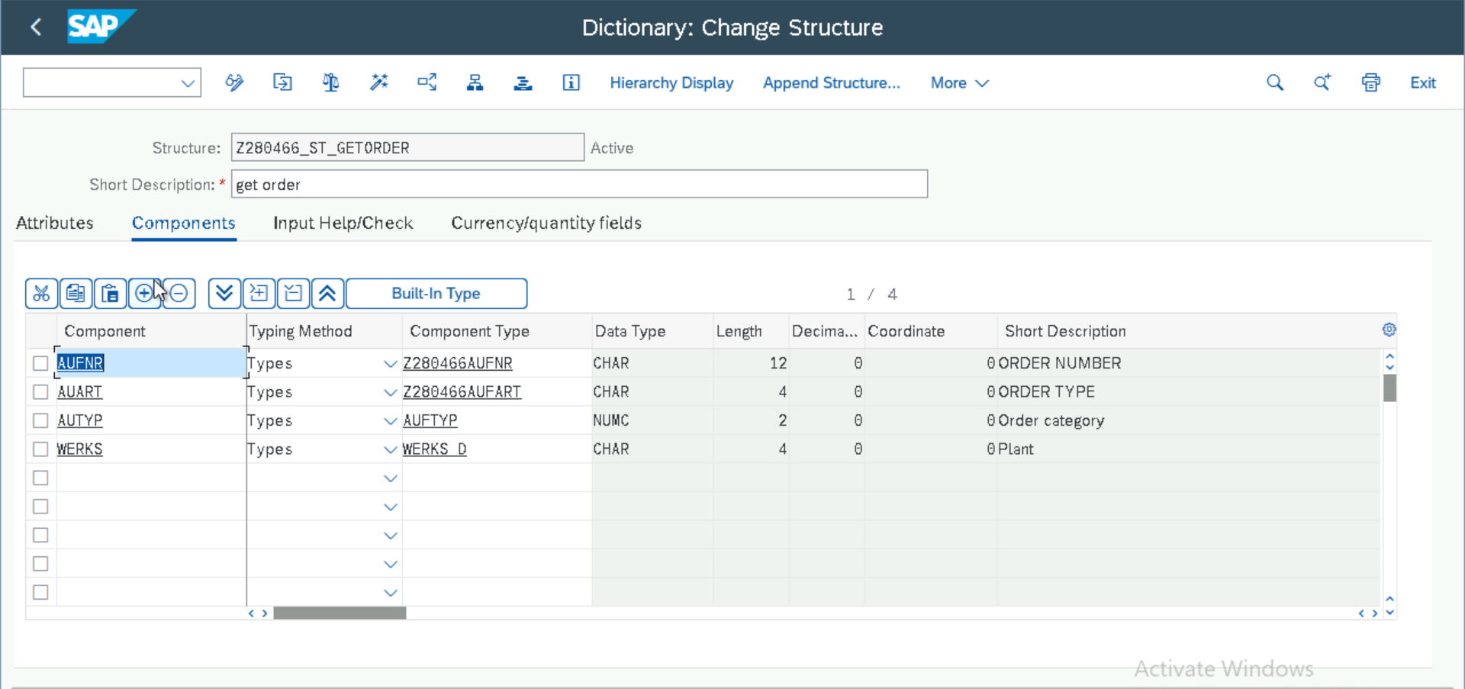

Table Type:

Function Module: Attributes

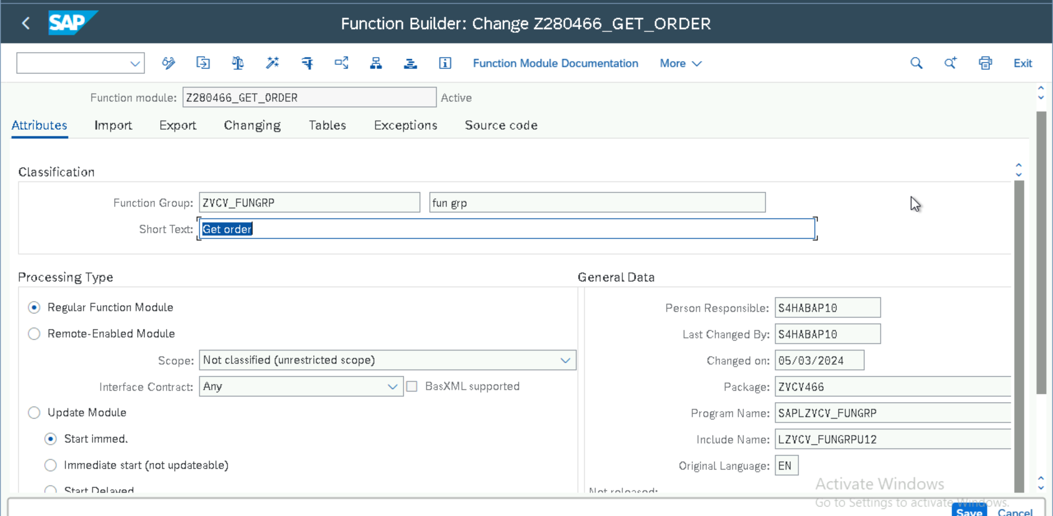

Function Module: Import

Function Module: Tables:

Function Module: Source Code

Function Module: Executable Program

Selection Screen:

Function Module: Output

